Gas / Propane Insert Buying Guide
A gas or propane insert is designed to fit into an existing wood fireplace opening. There are numerous choices and options available when looking for an insert and the team at Maple Mtn Fireplace is here to help every step of the way. Buying an insert is a long-term decision that will provide years of worry-free enjoyment, and to help with your decision, we’ve assembled some information that every new gas insert customer should know.

Will the insert fit?
Gas inserts are designed to fit into most masonry fireplaces. Should one not fit, most makes and models have 3 sizes – so we should be able to recommend a similar alternative.

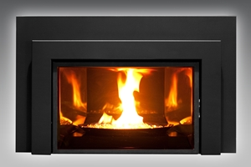
What do gas inserts cost?
A gas insert will cost anywhere from $2,000 - $5,000. A gas insert fully installed (fireplace, venting, labor, taxes, gas pipe….) will typically cost between $3,500 to $6,500.

Are Monthly Payments Available?
Yes. We offer financing for 12 month, no interest.

How long does it take to get a fireplace insert installed?
We recommend that a customer make a decision on what fireplace they would like installed at least 2 months prior to the desired installation date. This will allow enough time for Maple Mtn Fireplace to inspect the area, order and stage the product (back orders do happen), as well as schedule a convenient time to install the appliance. It can be beneficial to have an insert installed in the off-season – as roofs are safer and more scheduling flexibility.

How much will it cost me to run my insert?
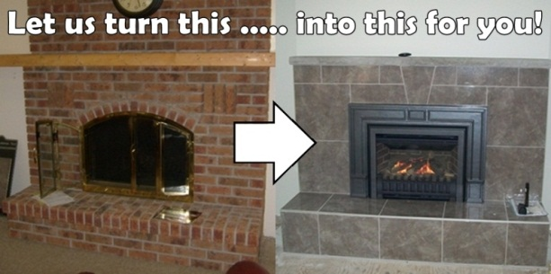
Annual operating costs vary depending on how often the appliance is used, how large the appliance is, how efficient the appliance, is, and the type of fuel (propane vs. natural gas). As a general rule, natural gas is less than half the cost of propane, whereas propane costs less than oil & electricity.

I don’t like the brick around my fireplace – can it be changed?
Yes. Brick (or stone) can be painted, covered or removed and replaced with something non-combustible.

What ‘BTU’ heat output do I need?
BTU is not always a proper indication of heat output for an insert – so we recommend that this rating be used as a general guideline on fuel usage only as it cannot be relied upon when making a fireplace decision. Speak with your Maple Mtn Fireplace Sales Associate and describe your room size and desired amount of heat, and we can recommend the best unit.

Is all gas / propane venting created equal?
No. Maple Mtn Fireplace uses a high quality vent liner system as well as a deluxe high wind cap to ensure you’ll never need to replace the venting and that wind (or critters) will not affect the enjoyment of your fireplace.

Should my insert be the only heat source for a home or cabin?
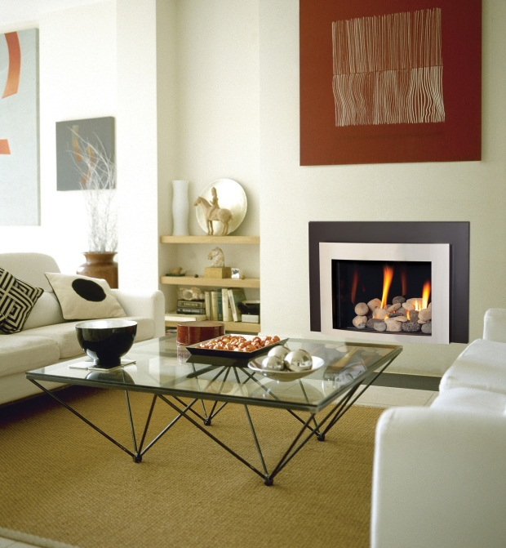
It’s not recommended for the following reasons. 1. Most insurance companies will not insure your home or cabin if fireplaces are the only heat source; 2) A gas insert is not as reliable as other heating products (such as central heating); and 3) Should service work be required, most fireplace manufacturers require a few days (sometimes weeks) to ship parts – so immediate turnaround service is not possible.

Do inserts require electricity?
Yes and no. Some inserts require electricity, some require electricity only for a blower and some are completely power independent and can therefore be used during a power outage or as a furnace back-up. If this important for you, please discuss with your Maple Mtn Fireplace Sales Associate.

Are fireplace blowers loud?
Yes, they can be. Although Maple Mtn Fireplace’ fireplaces have the highest quality blowers available, any blower not on its lowest setting will be loud. Maple Mtn Fireplace recommends that blowers be kept on their lowest settings, as its been our experience that faster fan speeds do not necessarily result in more heat – but faster speeds do result in noise (think of the fan speed in your car heater – it remains on low except during defrost).

If the insert I choose requires electricity – where will the electrical cord be?
If an electrician is hired prior to a Maple Mtn Fireplace installation, he / she can place an electrical outlet inside the wood fireplace cavity (should there be room). If there is no room and / or the customer chooses not to hire an electrician, then an electrical cord will be present along the hearth of the fireplace.

Should pilot lights be left on or off?
Maple Mtn Fireplace recommends that a pilot light be left on at all times – even if the insert is equipped with electronic pilot ignition (IPI). It’s been our experience that turning pilot lights off – even electronically – is the #1 cause of service issues. In addition, by leaving a pilot light on, moisture and insects are kept out of the burner area prolonging its lifespan.

Will the flame of my insert look the same as the brochure? Showroom?
No. Many factors influence the height, size and look of fireplace flames. For example, propane inserts have smaller flames than natural gas inserts.

Will the flashing around the insert be flush with my fireplace?
No. The gas insert will only be as flush or symmetrical as the existing wood fireplace will allow. Our technicians will do their best to level the fireplace, but the existing wood fireplace will influence the final design.

Can my contractor install a Maple Mtn Fireplace fireplace?
Yes. Your licensed contractor can install a Maple Mtn Fireplace fireplace. However, should a warranty or service issue arise, it is the RESPONSIBILITY of the contractor who installed the insert to diagnose, fix, and provide warranty support (if any) for the appliance. Maple Mtn Fireplace technicians may not be able to properly diagnose a recently installed insert by your contractor.

BBQ or Outdoor Fireplace Gas Line
If we are installing an insert, you may be interested in having Maple Mtn Fireplace provide a propane or gas line for your existing (or new) BBQ or outdoor firepit. Its inexpensive to run a gas line while our technicians are on-site. In addition, if you are looking for a BBQ (or other fireplace), we offer quantity discounts should we be able to deliver both items on the same day.

The Maple Mtn Fireplace Process
Should you choose to proceed with Maple Mtn Fireplace, our Sales Associate will ensure to get the answer to the following question: “What are the 2-3 things we can do to make sure you remain satisfied with our relationship?” This information will be shared with our sales team, technicians, service department as well as our administration team to ensure we meet and exceed your expectations every step of the way.

Why Maple Mtn Fireplace?
There are a lot of great fireplace companies in our industry. We hope you choose us for our amazing people. We would love you to become part of the Maple Mtn Fireplace Family.
Other great reasons why our customers return for our high level of service include:
- Maple Mtn Fireplace 100% price match guarantee ensures you are making a wise investment
- During installation, we will come to your home to show you how to operate your insert and answer any questions you may have
- We treat your home like our home.
- Maple Mtn Fireplace has a full-time in-house service department
- Our technicians are professional, courteous, & certified
- Maple Mtn Fireplace is 100% covered by liability and Workers Comp insurance. Any contractor who is not covered and gets injured in a home could go against the home policy.
- Experience: We have over 25 years of experience & have installed thousands of fireplaces.
- After any fireplace purchase, you automatically get enrolled in the Maple Mtn Fireplace Customer Preferred Program – offering you valuable discounts on your future service, fireplace, BBQ or solar purchases.
- We focus and care: Maple Mtn Fireplace is your gas insert specialist

Don’t take our word for it – feel free to browse comments from some of our customers on Google

