Gas / Propane Freestanding Stove Buying Guide
When looking for a gas or propane freestanding stove, numerous choices and options are available. Maple Mtn Fireplace is here to help every step of the way. Buying a stove is a long-term decision that will provide years of worry-free enjoyment, so ensuring the right stove is installed is very important. To help with your decision, we have assembled some information that every new customer may want to know.

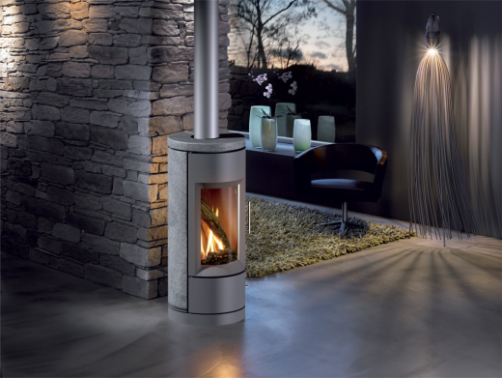
What do gas / propane stoves cost?
A gas stove alone will cost anywhere from $2,000 - $6,500. A stove fully installed (stove, venting, labor, taxes, gas pipe….) typically costs from $3,500 to $6,000.

Are monthly payments available?
Yes, we offer 12 month financing with no interest.

How much will it cost me to run my stove?
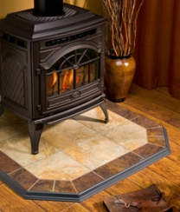
Annual operating costs vary depending on how often the appliance is used, how large the appliance is, how efficient the appliance, is, and the type of fuel (propane vs. natural gas). As a general rule, natural gas is less than half the cost of propane, whereas propane costs less than oil & electricity.

Do gas stoves require a non-combustible base?
Yes and No. As a general rule, most gas / propane stoves on legs require a non-combustible (tile, stone, concrete) or real hardwood base, whereas most gas / propane stoves on pedestals can be installed directly on anything. Should the stove you choose require a non-combustible base, Maple Mtn Fireplace can provide pre-made tile boards that can be easily installed.

Should my stove be the only heat source for a home or cabin?
It’s not recommended for the following reasons: 1) Insurance companies will not insure your home or cabin if a gas stove is the only heat source; 2) A gas stove is not as reliable as other heating products (such as central heating) and 3) Should service work be required, most fireplace manufacturers require a few days (sometimes weeks) to ship parts – so immediate turnaround service is not possible.

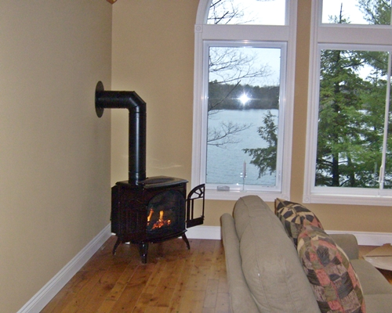
What BTU heat output do I need?
Because BTU is not a proper indication of heat output for a stove, we recommend that this rating be used as a general guideline on fuel usage only, as it cannot be relied upon when making a fireplace decision. In addition, manufacturer ‘recommended heating areas’ are very broad general guidelines and should not be taken as a primary decision for a specific stove or fireplace (these same brochures go to Texas).

Are stoves as efficient as furnaces?
No – but it depends how you calculate efficiency. Most heat produced from a stove goes into the living space at the time where the homeowner needs / requests the heat. A furnace will heat unused areas of a home whether the home owner is home or not, and furnaces efficiencies do not account for heat loss in ductwork. Therefore, some argue that heat from a stove is more efficient – even if technically – they use more fuel per amount of heat produced.

Do stoves require electricity?
Yes and no. Most gas or propane stoves sold by Maple Mtn Fireplace do not require electricity and are therefore excellent heat backup options. If you elect to have a blower installed on the stove, it will require electricity to function.

Are Blowers Required?
Depending on the size of the room, desired function of the stove, and size of the stove – a blower may or may not be required. Because most blowers can be installed at a later date without moving the stove, many customers elect to install a stove without a blower.

Should pilot lights be left on or off?
There are a number of different opinions on this topic. Maple Mtn Fireplace recommends that a pilot light be left on at all times – even if the stove is equipped with electronic pilot ignition (IPI). It has been our experience that turning pilot lights on, even electronically, is the #1 cause of service issues. In addition, by leaving a pilot light on, moisture and insects are kept out of the burner area, prolonging its lifespan.

How long does it take to get a stove installed?
We recommend that a customer make a decision on what fireplace they would like installed 2 months prior to the desired installation date. This will allow for enough time for Maple Mtn Fireplace to inspect the area, order and stage the product, as well as schedule a convenient time to install the appliance. In addition, it can be beneficial to have a stove installed in the off-season as roofs are safer and there is more flexibility from a scheduling standpoint.

Can I vent my stove into an existing wood chimney?
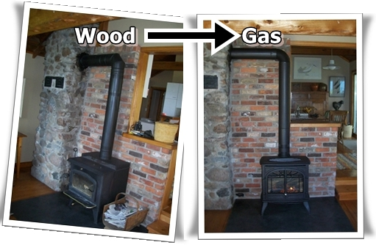
Yes. Some gas or propane stoves can vent into existing wood chimneys. If you do not have an existing wood chimney, a gas or propane stove can also be vented out the wall or through the roof.

Will the flame of my stove look the same as the brochure? Showroom?
No. Many factors influence the height, size and look of your flames. For example, propane and rear-vented units will have smaller flames than natural gas or top vented units.

Can my contractor install a Maple Mtn Fireplace gas stove?
Yes. Maple Mtn Fireplace will sell you the appliance if you have a licensed contractor who can install the stove. However, should a warranty or service issue arise, it is the RESPONSIBILITY of the contractor who installed the stove to diagnose, fix, and provide warranty support (if needed) for the appliance. Maple Mtn Fireplace technicians may not be able to properly diagnose a recently installed stove. Please strongly consider this point prior to having someone else install a gas stove.

Gas or Propane Stoves – Below Grade (if applicable)
If your gas or propane stove is being installed in an area below grade, the gas line will be visible along the wall as we enter the house – unless – the gas line is run BEFORE drywall and/or the customer removes the drywall prior to our installation date.

BBQ Line or Outdoor Firepit
If we are installing a stove, you may be interested in having Maple Mtn Fireplace provide a propane or gas line for your existing (or new) BBQ or future outdoor fire pit. It’s more economical to run a gas line while our technicians are already on-site. In addition, if you are looking for a BBQ (or other fireplace), we offer quantity discounts should we be able to deliver both items on the same day.

The Maple Mtn Fireplace Process
Should you choose to proceed with Maple Mtn Fireplace, our Sales Associate will ensure you get the answer to the following question: “What are 2-3 things we can do to ensure you remain satisfied with our relationship?” This information will be shared with our sales team, technicians, service department as well as our administration team to ensure we meet and exceed your expectations every step of the way.

Why Maple Mtn Fireplace?
There are a lot of great fireplace companies in our industry. We hope you chose us for our great people. We would love you to join the Maple Mtn Fireplace Family. Other great reasons why our customers return for our high level of service include:
- Maple Mtn Fireplace 100% price match guarantee on same product – this ensures you are making a wise investment
- We treat your home like our home: We use courteous, certified, full-time, licensed fireplace installers
- After installation, we will show you how to operate the fireplace and answer any questions you may have
- Maple Mtn Fireplace has a full-time in-house service department
- Our technicians are clean, personable & certified
- Maple Mtn Fireplace is 100% covered by liability and Workers comp insurance ensuring no possible claim could go against the home owner (unlike a contractor who does not have proper coverage)
- Experience: We have been in business for over 25 years and have installed and serviced thousands of stoves and fireplaces.
- After any stove purchase, you automatically get enrolled in the Maple Mtn Fireplace Customer Preferred Program – offering you valuable discounts on your future service, fireplace, BBQ or solar purchases.
- The gas vent we use is of the highest quality, ensuring the cleanest look and longest lasting vent available on the market today (i.e. insulated thimbles & stainless steel inner liner)
- We focus and care: Maple Mtn Fireplace is your fireplace specialist

Don’t take our word for it – feel free to browse comments from some of our customers on google!

