Gas/Propane Fireplace Buying Guide
Interested in a gas or propane fireplace? The team at Maple Mtn Fireplace is here to help every step of the way. A fireplace is a long-term investment and is often the focal point of the room (home / cabin) - so choosing the right fireplace is very important. To help, the team at Maple Mtn Fireplace has assembled some information to assist anyone moving through this process.

How much do fireplaces cost?
Gas fireplaces will cost anywhere from $2,000 - $8,000. A gas fireplace fully installed (fireplace, venting, labour, taxes, gas pipe….) typically costs between $2,500 & $9,500. These prices do not include finishing costs which can range from simple drywall (~$750) – to decorative marble or stone ($5,000+?). Maple Mtn Fireplace provides a wide variety of fireplaces to suit all budgets.

Are monthly payments available?
Yes. 12 months financing with no interest is available.

Can I place my television above my fireplace?
Yes. Different fireplaces have different heat clearance requirements. If this is important, please mention it to your Maple Mtn Fireplace sales associate and he / she will guide you to the more appropriate fireplaces.

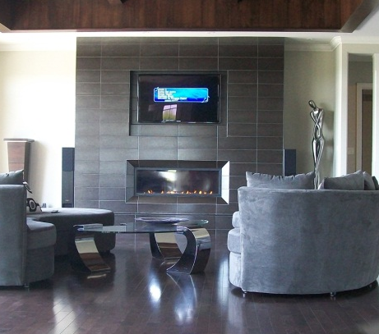
Do fireplaces require a non-combustible area in front of the fireplace?
Some fireplaces do, and some don’t. These requirements are specific to the chosen fireplace and are clearly listed in the manual for the appliance.

How much will it cost to run my fireplace?
Annual operating costs vary depending on how often the appliance is used, how large the appliance is, how efficient the appliance is and the type of fuel used (propane vs. natural gas). As a general rule, natural gas is less than half the cost of propane, whereas propane costs less than oil & electricity.

Should fireplaces be the only heat source for a home or cottage?
No. It’s not recommended for the following reasons: 1) Most insurance companies require alternate heat sources; 2) A gas fireplace is not as reliable as other heating products (such as central heating); and 3) Should service work be required, most fireplace manufacturers require a few days (sometimes weeks) to ship parts – so immediate turnaround service is not possible.

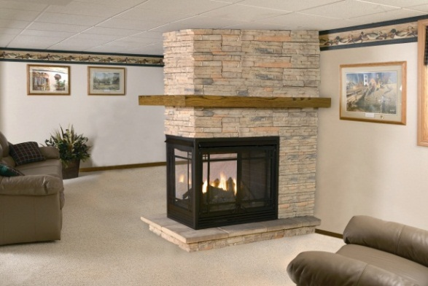
What BTU heat output do I need?
Because BTU is not a proper indication of heat output for a fireplace, we recommend that this rating be used as a general guideline on fuel usage only – as it can not be relied upon when making a fireplace decision. In addition, manufacturer ‘recommended heating areas’ are very broad general guidelines and should not be taken as a primary decision for a specific fireplace. Consider: “Is this a small, medium or large fireplace?” or “Is this main purpose to supply heat or add to the ambiance of the room?”.

Are fireplaces as efficient as furnaces?
No – but it depends how you calculate efficiency. Most heat produced from a fireplace goes into the living space at the time where the homeowner needs / requests the heat. A furnace will heat unused areas of a home whether the home owner is home or not, and furnace efficiencies do not account for heat loss in ductwork. Therefore, some argue that heat from a fireplace is more efficient – even if technically they use more fuel per amount of heat produced.

Do fireplaces require electricity?
All fireplaces are different. Some require electricity for a blower and some are completely electric independent – and can therefore be used during a power outage or as a furnace back-up.

Should pilot lights be left on or off?
There are a number of different opinions on this topic. Maple Mtn Fireplace recommends that a pilot light be left on at all times – even if the fireplace is equipped with electronic pilot ignition (IPI). It has been our experience that getting a pilot light on – even electronically – is the #1 cause of service issues. In addition, by leaving a pilot light on, moisture and insects are kept out of the burner area prolonging its lifespan.

Seasonal Cabins or Areas (if applicable)
If a stove or fireplace is being installed in a seasonal cabin or area without regular heat, condensation and rusting will occur on or around the appliance. Surface rust is not covered by manufacturer warranty.

Are fireplace blowers loud?
Yes, they can be. Although Maple Mtn Fireplace fireplaces have the highest quality blowers available, any blower not on its lowest setting will be loud. Maple Mtn Fireplace recommends that blowers be kept on their lowest settings, as its been our experience that faster fan speeds do not necessarily result in more heat – but faster speeds do result in noise (think of the fan speed in your car heater – it remains on low except during defrost). Ask about our radiant heat fireplaces that do not require blowers.

How long does it take to get a fireplace installed?
Once a customer decides on a fireplace, a number of things begin to happen. From technical reviews, site visits, ordering & staging, dealing with mother nature and schedules - we recommend that a customer make a decision on what fireplace he / she would like installed at least 2 months prior to the desired installation date. Once a decision has been made, Maple Mtn Fireplace will ensure the fireplace is ordered and placed in a clean & safe environment so that no construction delay will occur due to product back orders (unfortunately – very common in the industry). Please note – fireplace manufacturers DO experience back orders on a regular basis.

Will the flame of my fireplace look the same as the brochure? Showroom?
No. Besides manufacturer ‘photoshoping’ of brochures, many factors influence the height, size and look of fireplace flames. For example, propane and rear-vented fireplaces will have smaller flames than natural gas or top vented units.

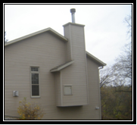
Can my contractor install our Fireplace?
Yes. Maple Mtn Fireplace will sell you the appliance if you have a licensed contractor who can install the fireplace. However: should a warranty or service issue arise, its the RESPONSIBILITY of the contractor who installed the fireplace to diagnose, fix, and provide warranty support (if any) for the appliance.

Can a fireplace be recessed into an outside wall?
Yes. A contractor could build a ‘bump-out’ thereby ensuring a flush finish with the inside wall. However, PRIOR to building a bump-out, it’s critical that the exact fireplace be chosen as well as an on-site visit from a Maple Mtn Fireplace technician in order to ensure proper width, depth AND height are taken into account for the bump-out.

Is all fireplace venting created equal?
No. Some venting is more expensive (higher quality) than others. Maple Mtn Fireplace recommends fireplace venting that uses stainless steel (instead of cheaper aluminum as it lasts longer) as well as higher quality components such as insulated thimbles (versus cheaper venting that does not). Once a fireplace is installed, venting is not easily changed should it break down.

BBQ Line & Complimentary Products
If we are installing a fireplace, you may be interested in having Maple Mtn Fireplace install a propane or gas line for your existing (or new) BBQ. Its inexpensive to run a gas line while our technicians are already on-site. In addition, if you are looking for a BBQ, other fireplace, or various accessories that will make your appliance more enjoyable (visit www.maplemtnfireplace.com for a complete listing), we offer quantity discounts should we be able to deliver both items on the same day.

Why Maple Mtn Fireplace?
There are many great fireplace companies in our industry. We hope you choose us for our people. We would love you to become one of the Maple Mtn Fireplace Family. Should you choose to proceed with Maple Mtn Fireplace, our Sales Associates will ensure to ask “What are the 2-3 things we can do to make sure you remain satisfied with our relationship?” This information will be shared with our sales team, technicians, service department as well as our administration team to successfully meet and exceed your expectations every step of the way. Other great reasons why our customers return for our high level of service include:
- Maple Mtn Fireplace 100% price match guarantee ensures you are making a wise investment
- After installation, we will show you how to operate the fireplace and answer any questions you may have
- We treat your home like our home: We use certified full-time licensed fireplace installers.
- Maple Mtn Fireplace has a full-time in-house service department
- Our technicians are professional, courteous, & certified
- Maple Mtn Fireplace technicians are covered by liability and worker’s comp insurance, so your home owner’s policy is protected.
- Experience: Our lead installers have installed and serviced thousands of fireplaces.
- After any fireplace purchase, you automatically get enrolled in the Maple Mtn Fireplace Customer Preferred Program – offering you valuable discounts on your future service, fireplace, BBQ or solar purchases.
- We focus and care: Maple Mtn Fireplace is your fireplace specialist
Don’t take our word for it – feel free to browse comments from our happy customers on our google review.
We hope you become a member of our family.

